|  |  |  |  |  |  |  |  |  |  |  |  |  |  |
| --- | --- | --- | --- | --- | --- | --- | --- | --- | --- | --- | --- | --- | --- |
|  | Bicubic interpolation | SRGAN-1  (50 epochs) | | SRGAN-1  (100 epochs) | | SRGAN-1  (150 epochs) | | SRGAN-1  (200 epochs) | | SRGAN-1  (250 epochs) | | SRGAN-1  (300 epochs) | |
| RMSE (wind, m/s) | 1,435 | 1,595 | 1,589 | 1,426 | 1,449 | 1,386 | 1,386 | 1,371 | 1,391 | 1,343 | 1,371 | 1,328 | 1,340 |
| RMSE (SLP, hPa) | 0,576 | 0,993 | 0,887 | 0,758 | 0,729 | 0,642 | 0,621 | 0,671 | 0,754 | 0,608 | 0,721 | 0,579 | 0,579 |
| RMSE-95 (m/s) | 1,898 | 2,555 | 2,621 | 2,194 | 2,298 | 2,106 | 2,189 | 2,079 | 2,188 | 2,006 | 2,144 | 1,982 | 2,087 |
| PSNR | 35,159 | 33,365 | 32,287 | 34,389 | 33,289 | 34,711 | 34,210 | 35,147 | 33,612 | 35,590 | 34,182 | 34,962 | 33,777 |

(1 January 2010 Low-Interp-High)

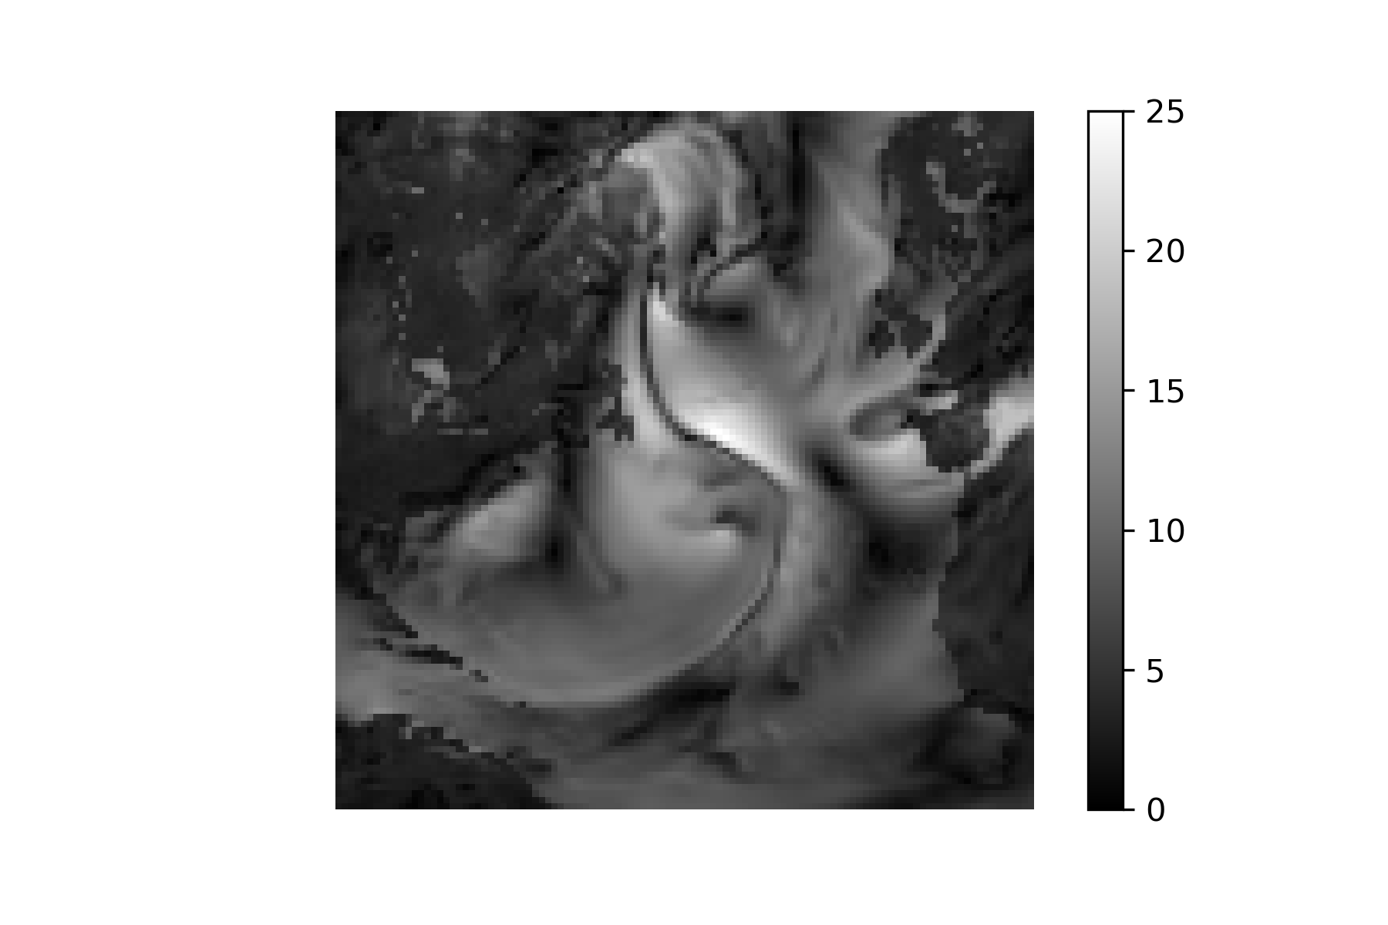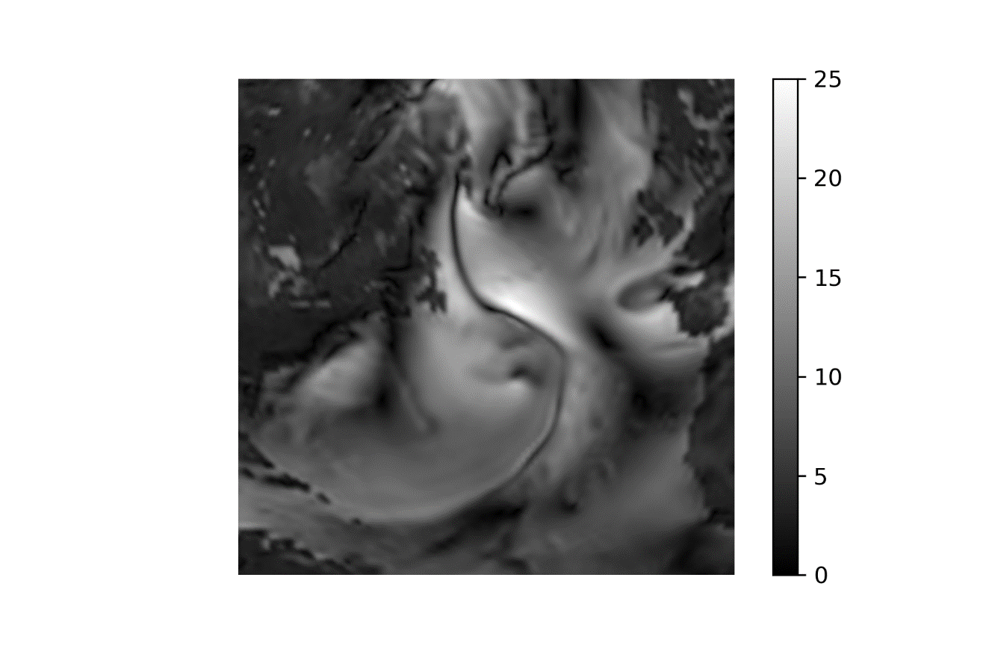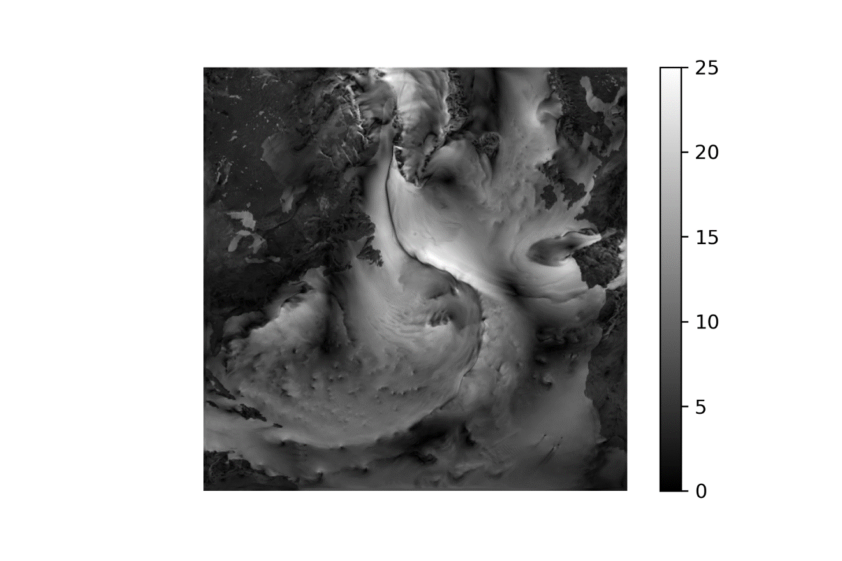

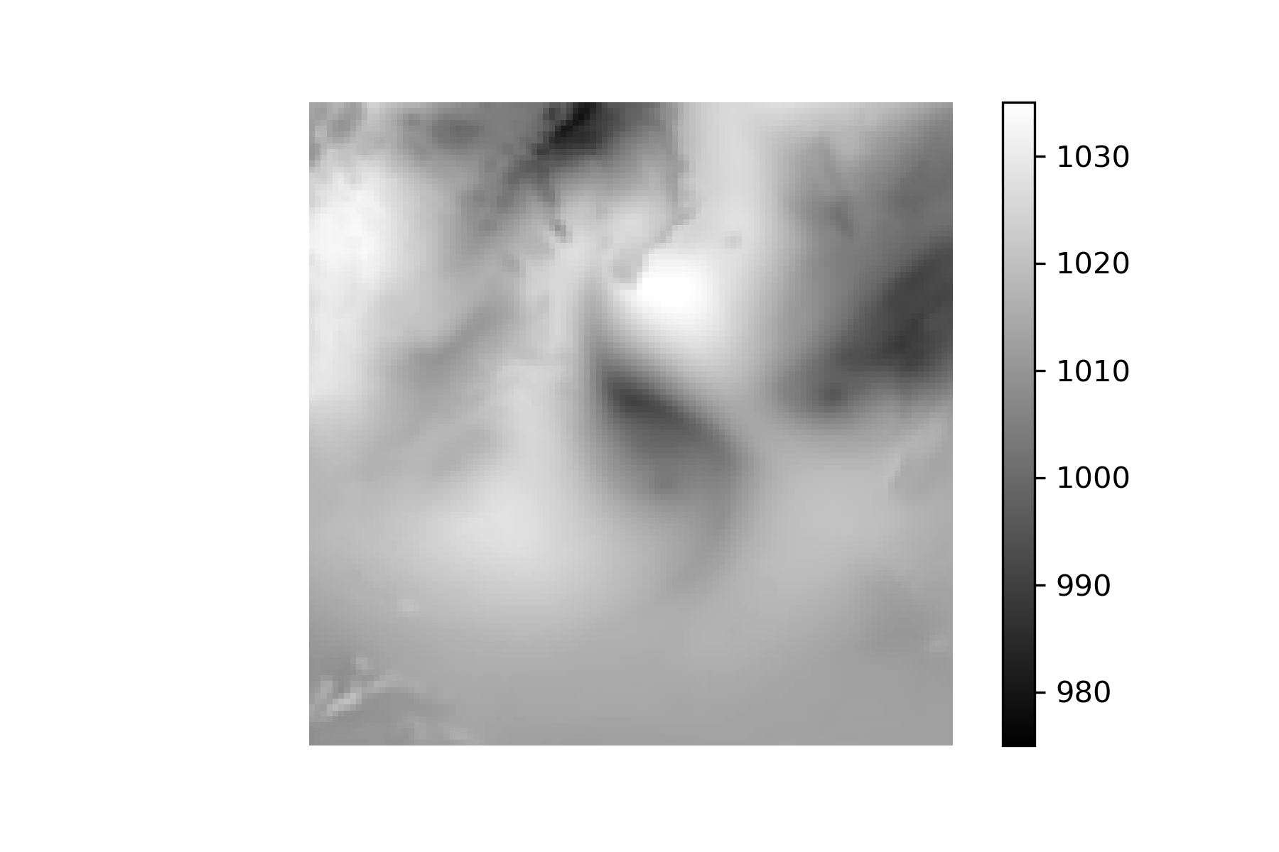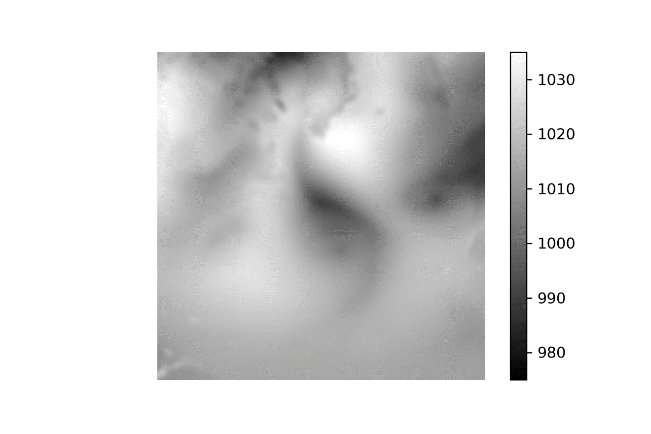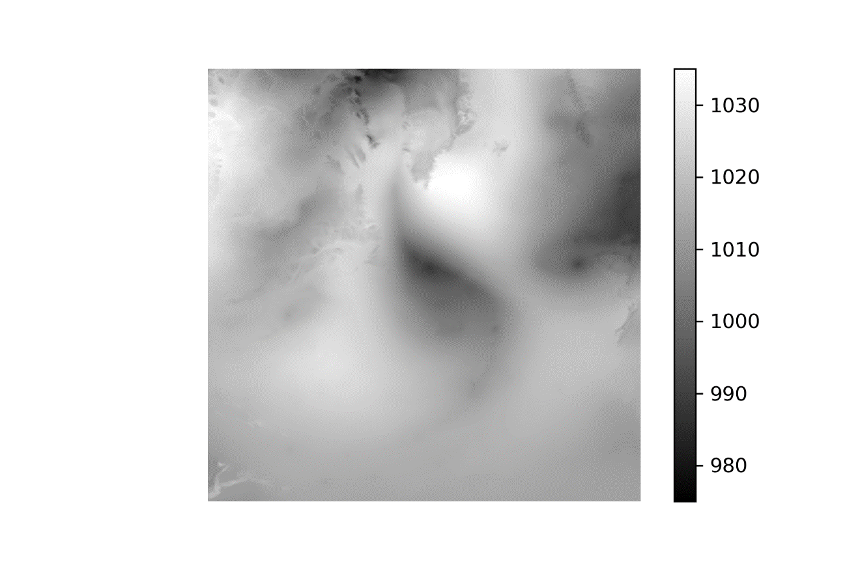

(1 Jul 2010 Low-Interp-High)

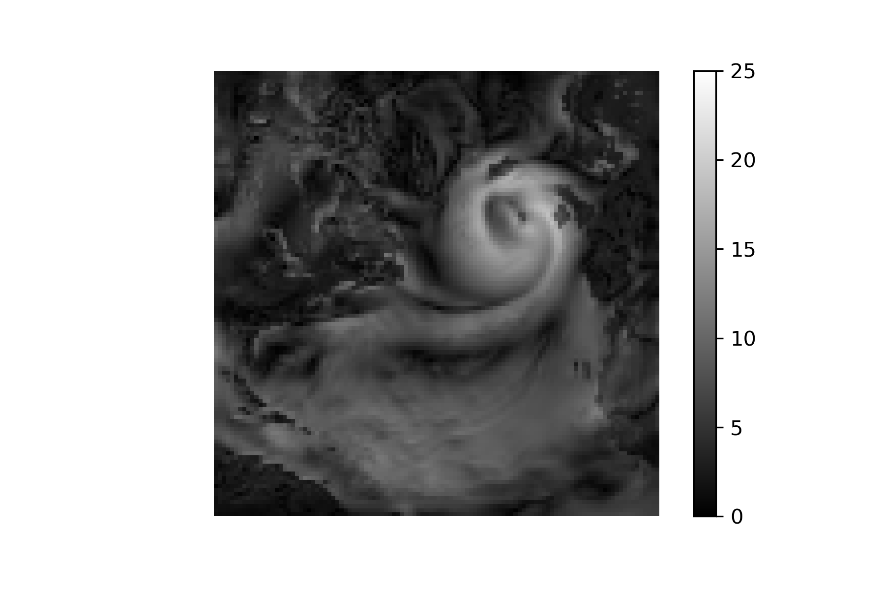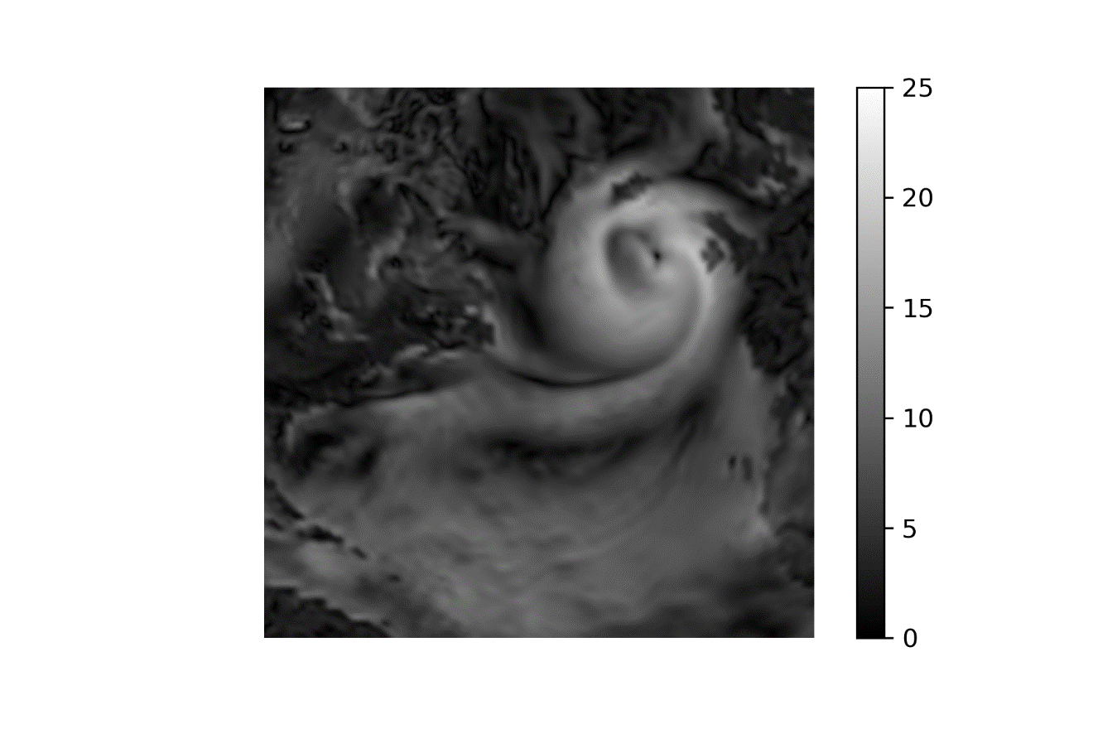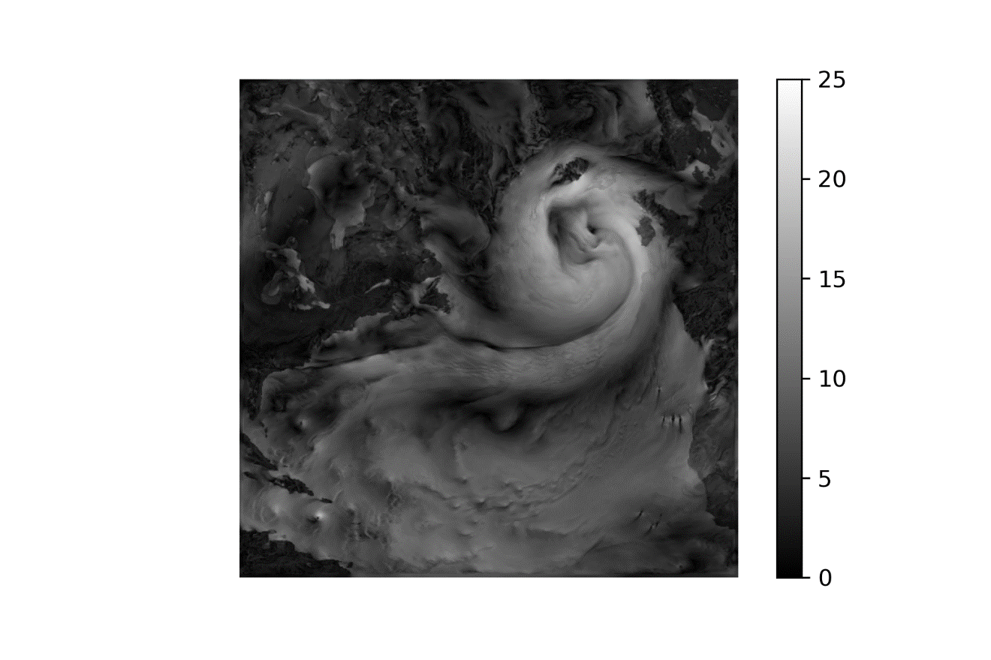

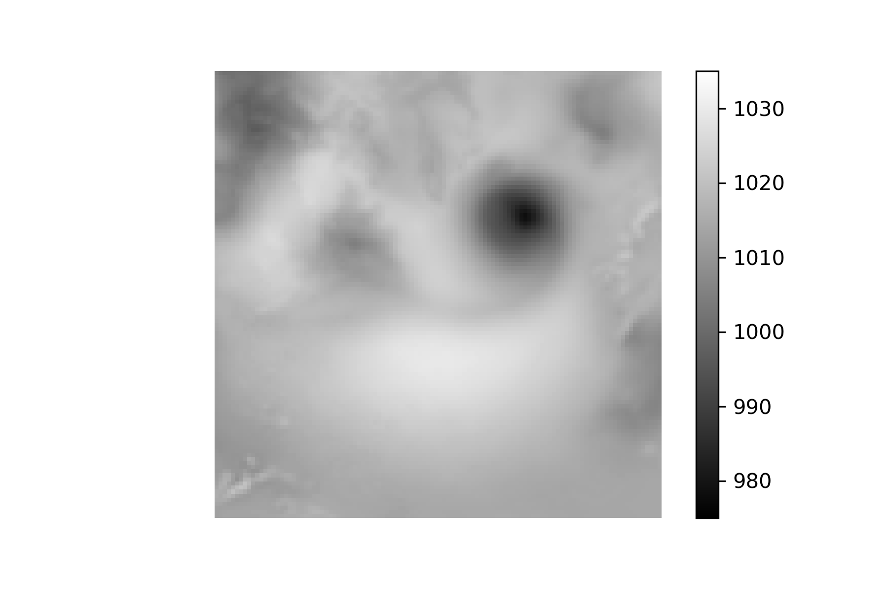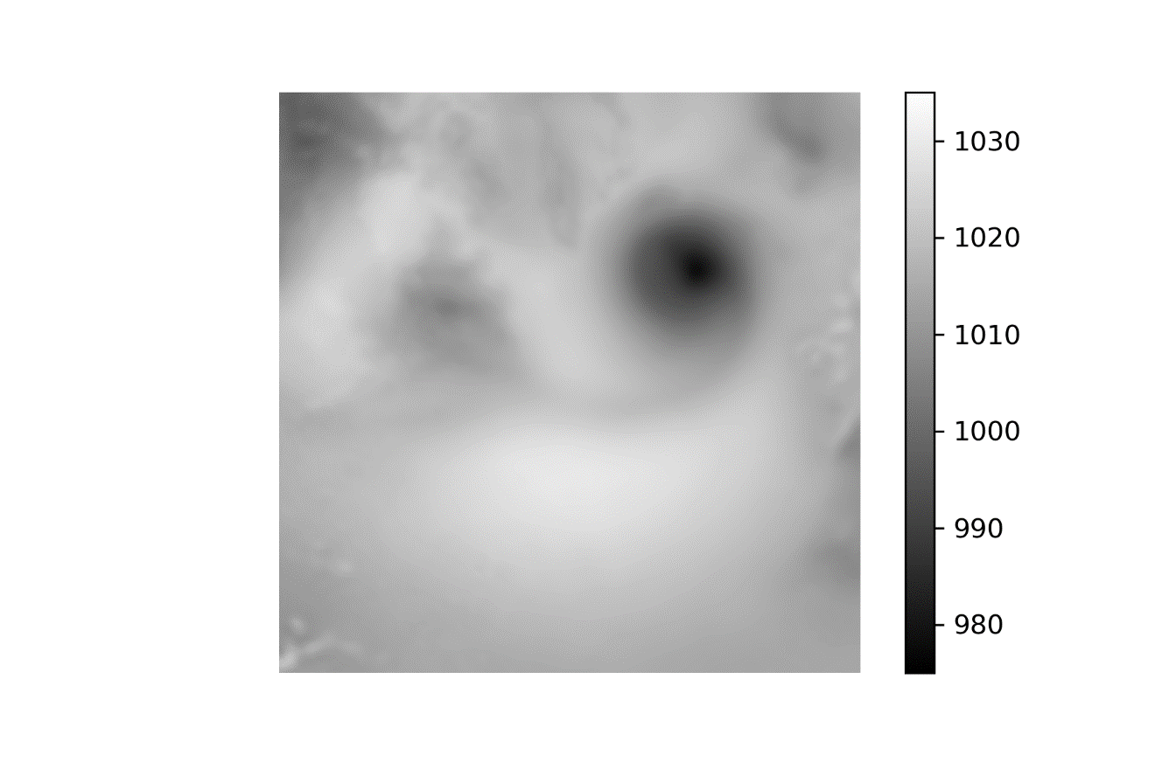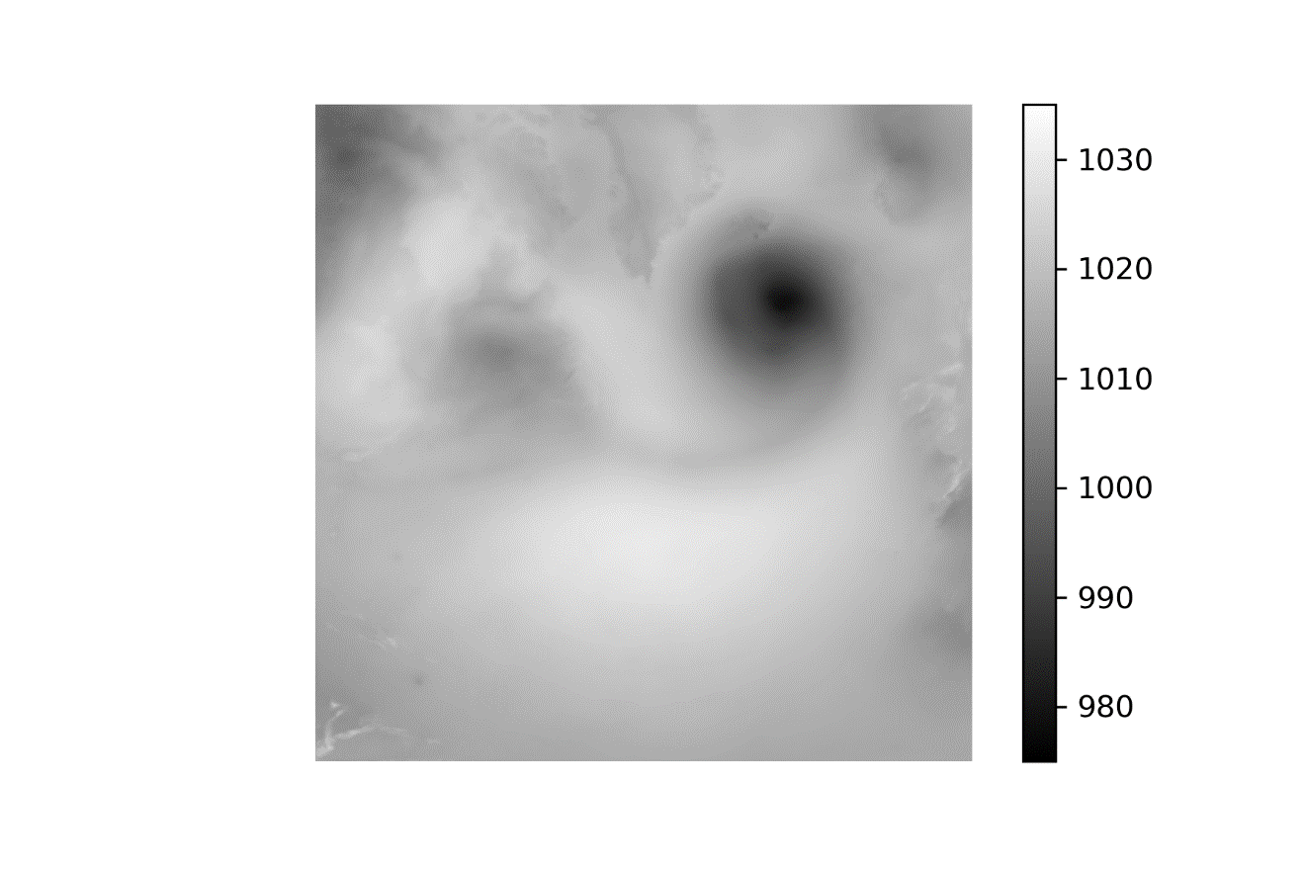

1 Jan 2010 –-50-100-150-200-250-300-High

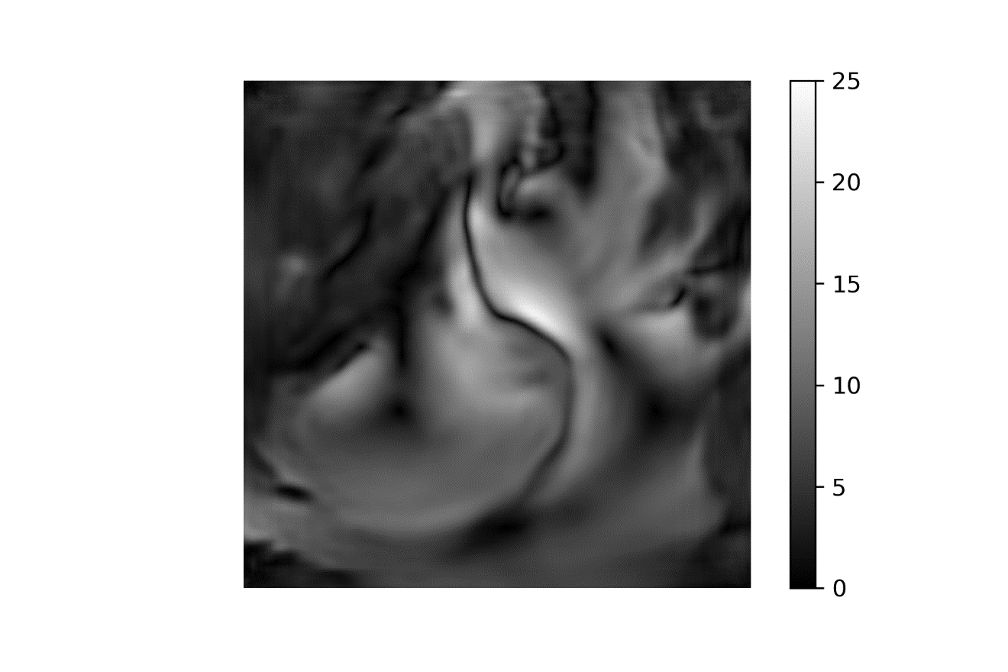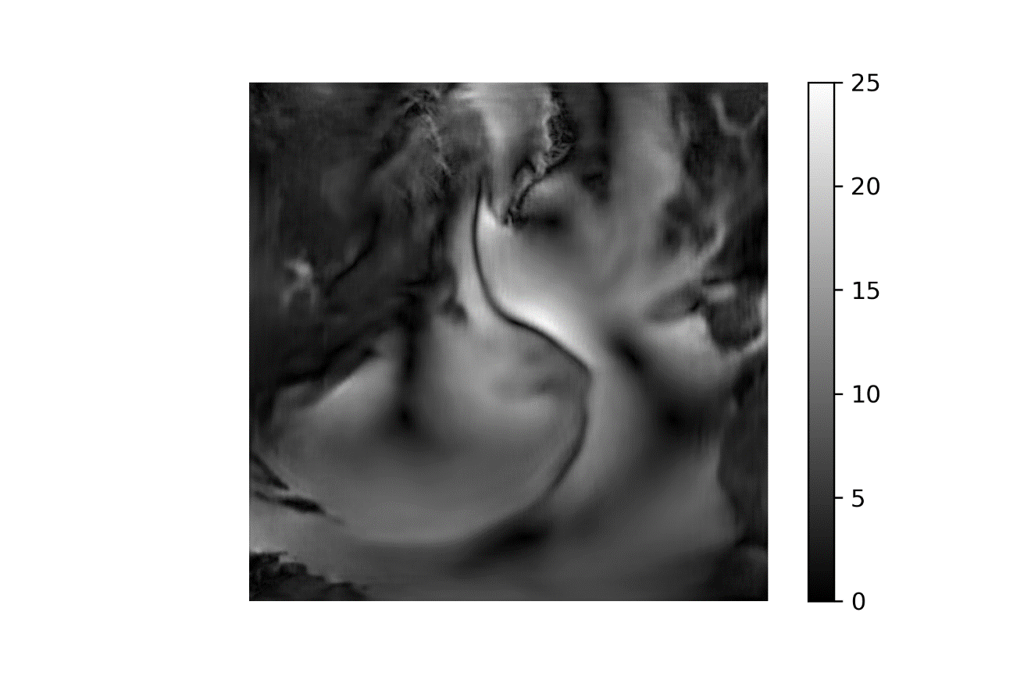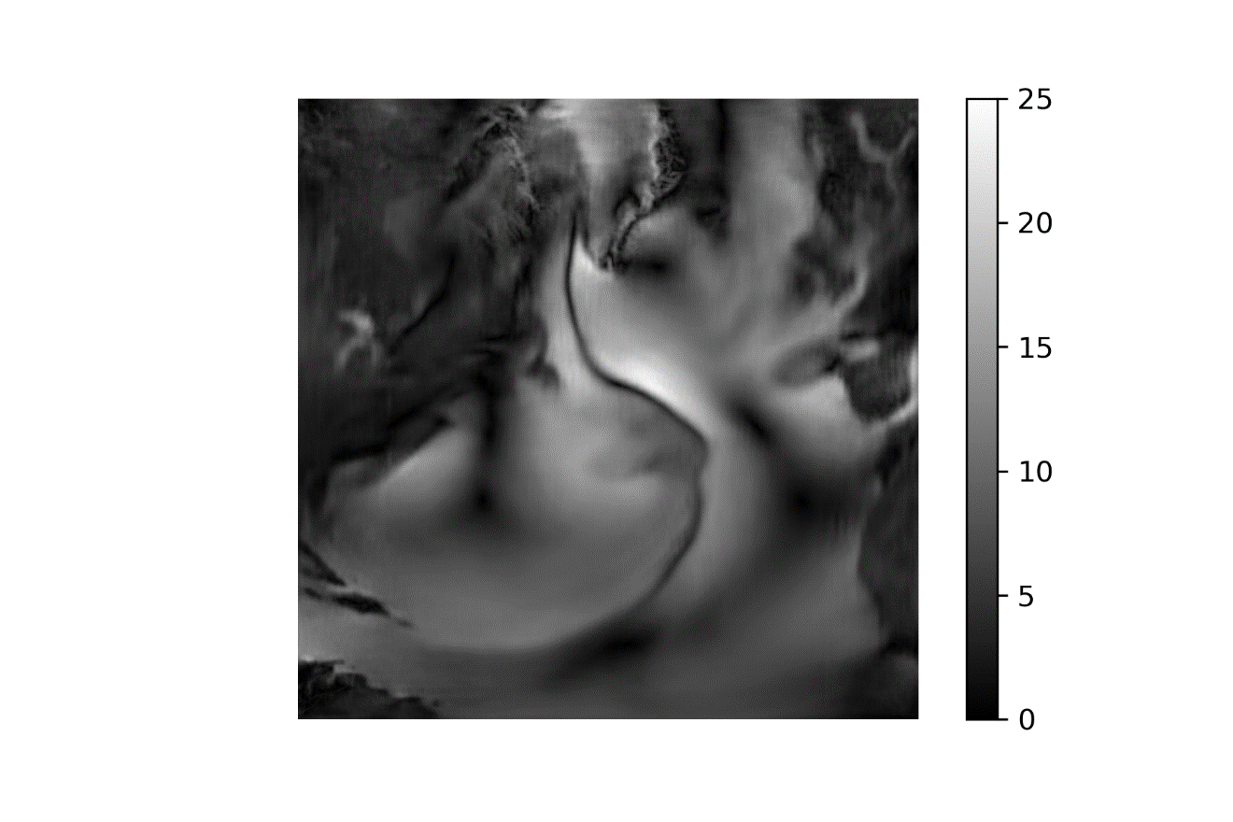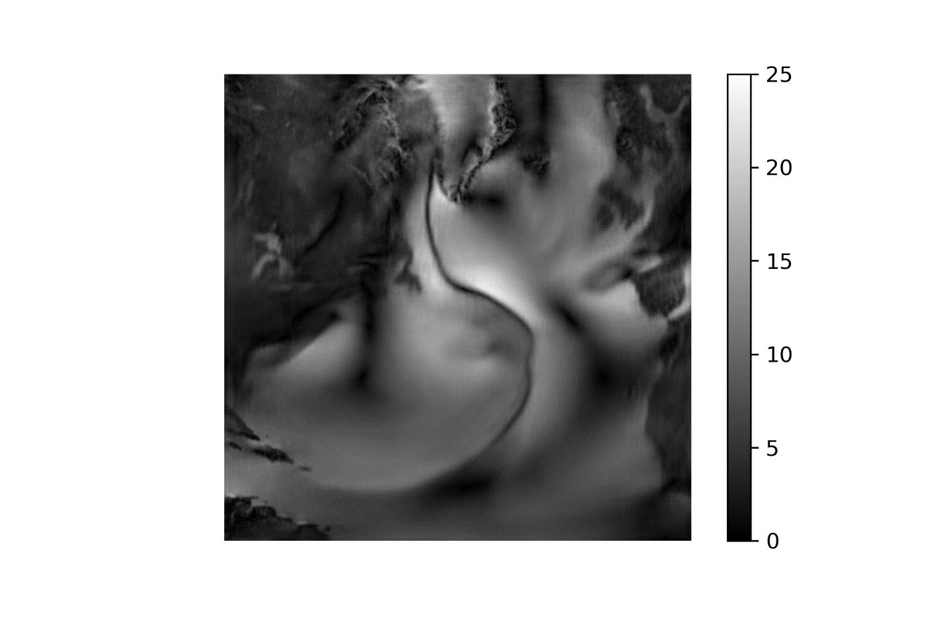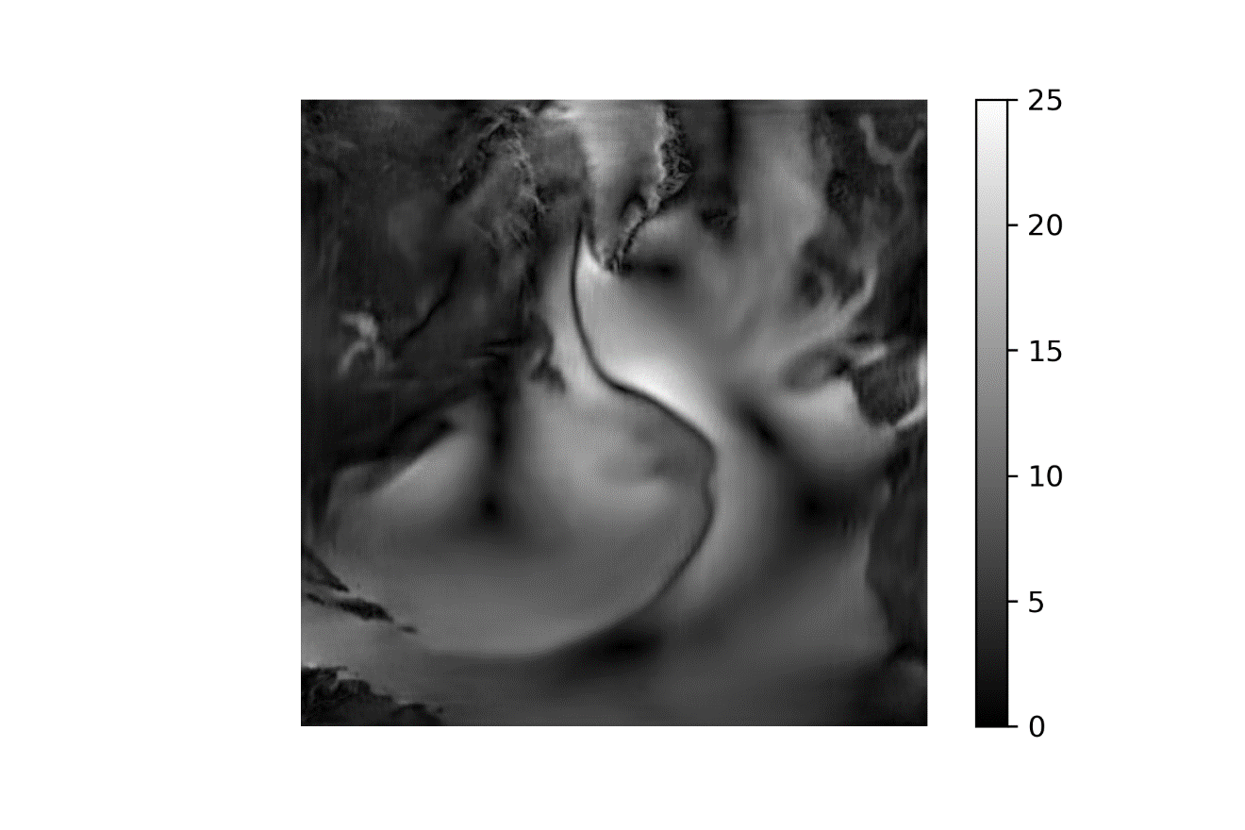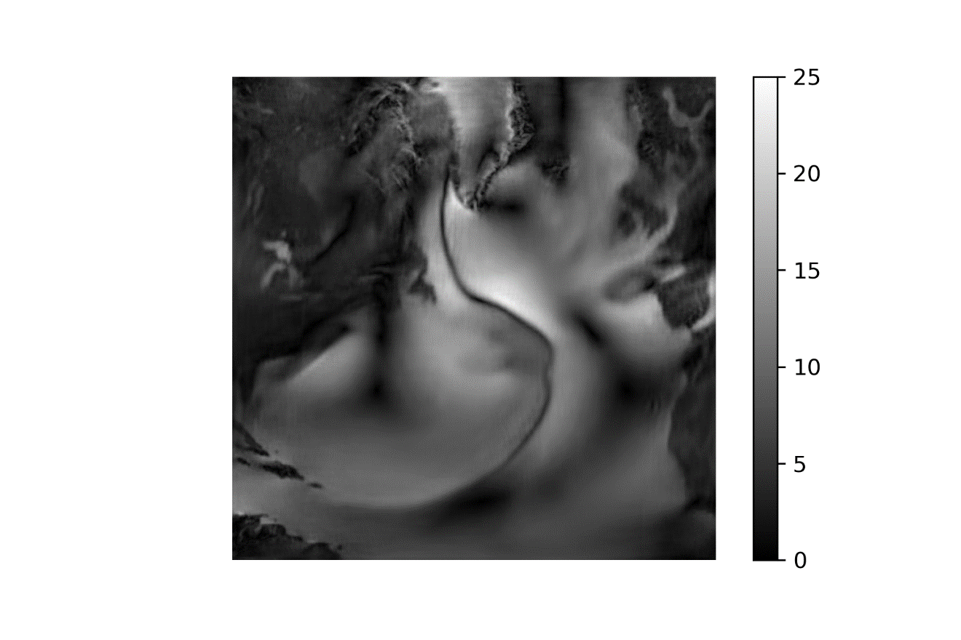



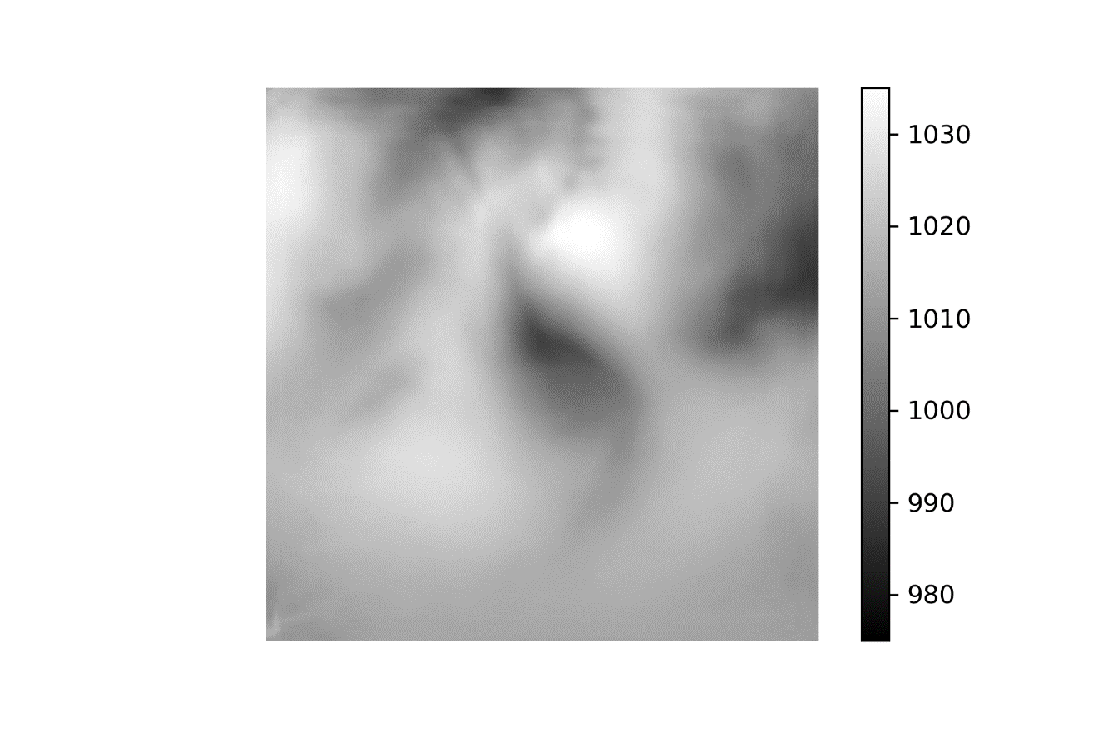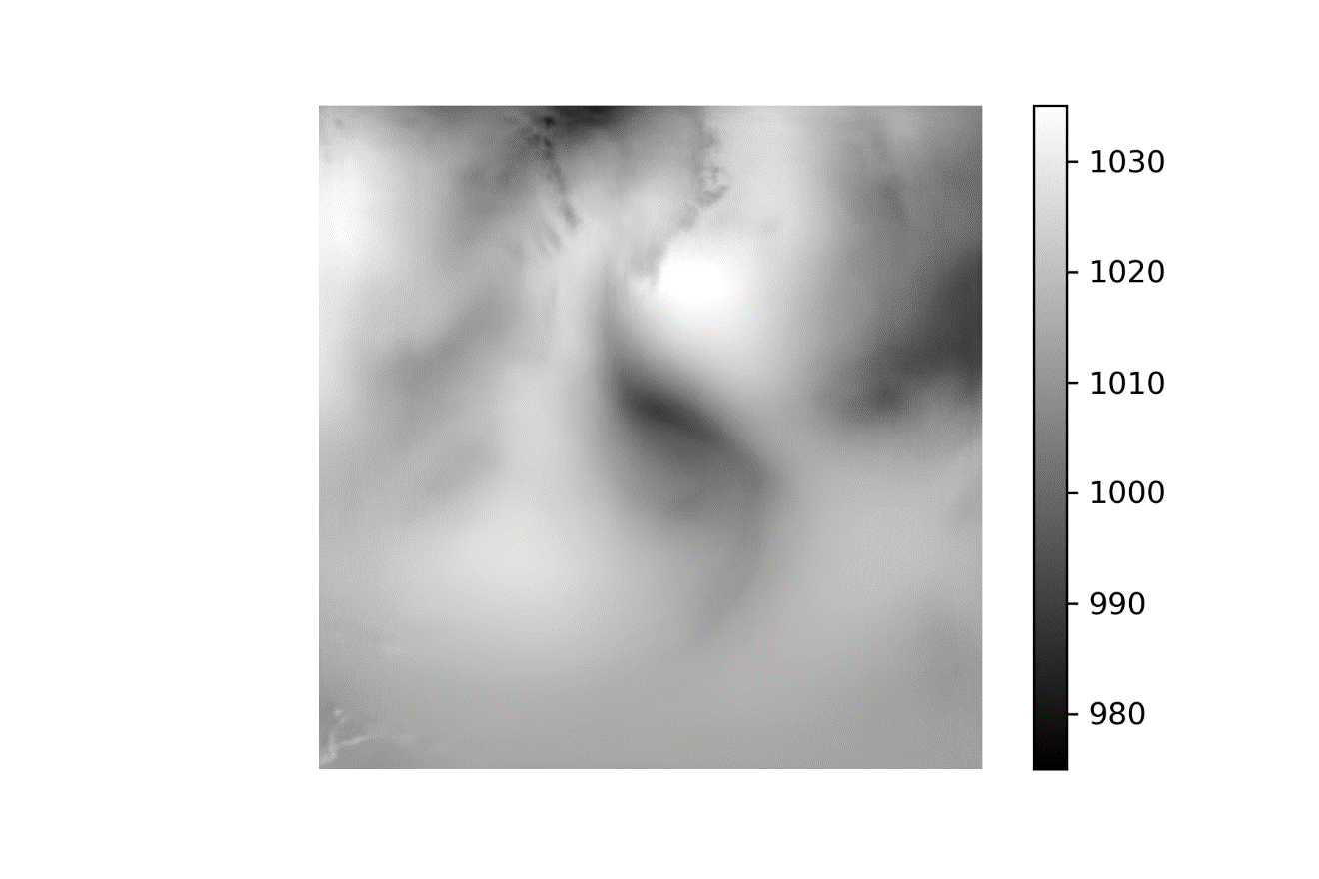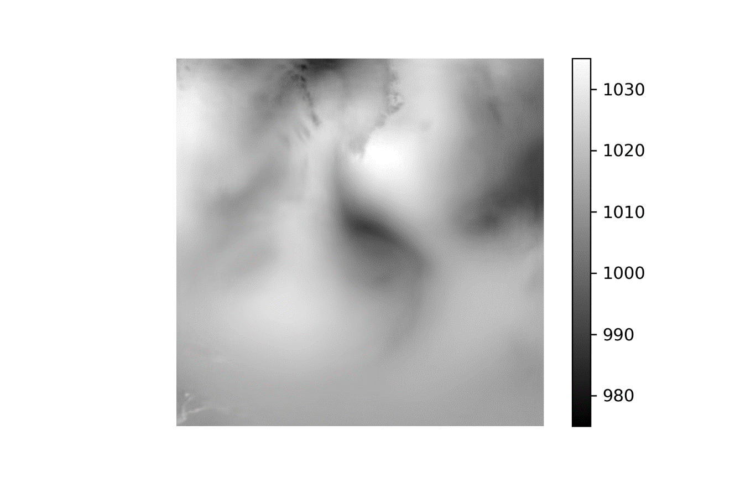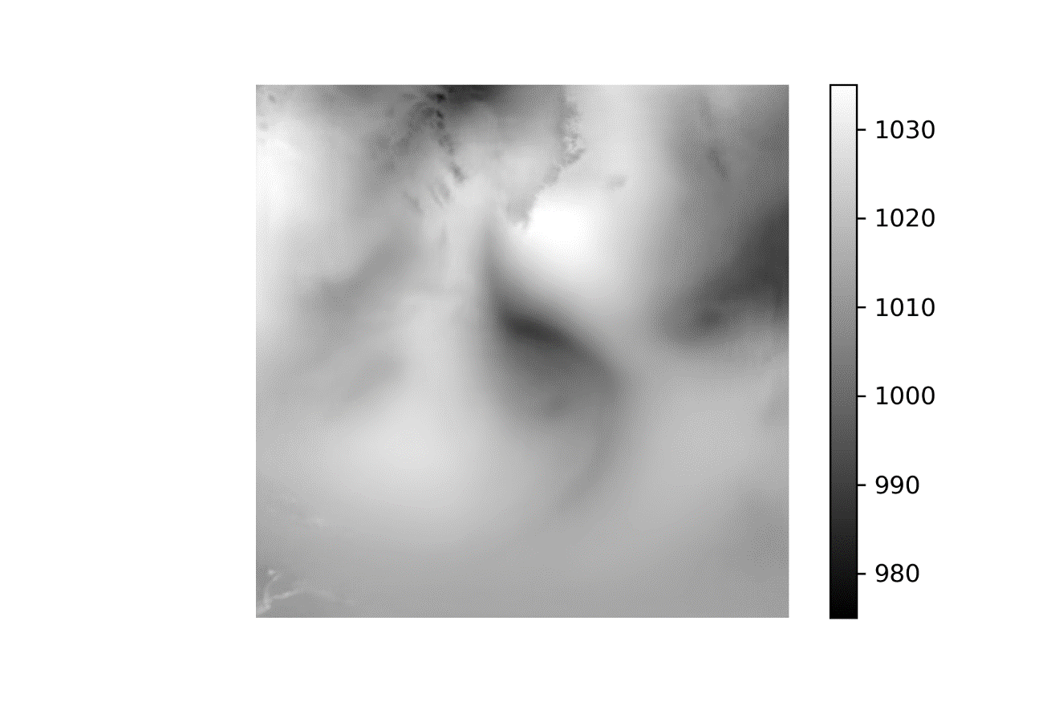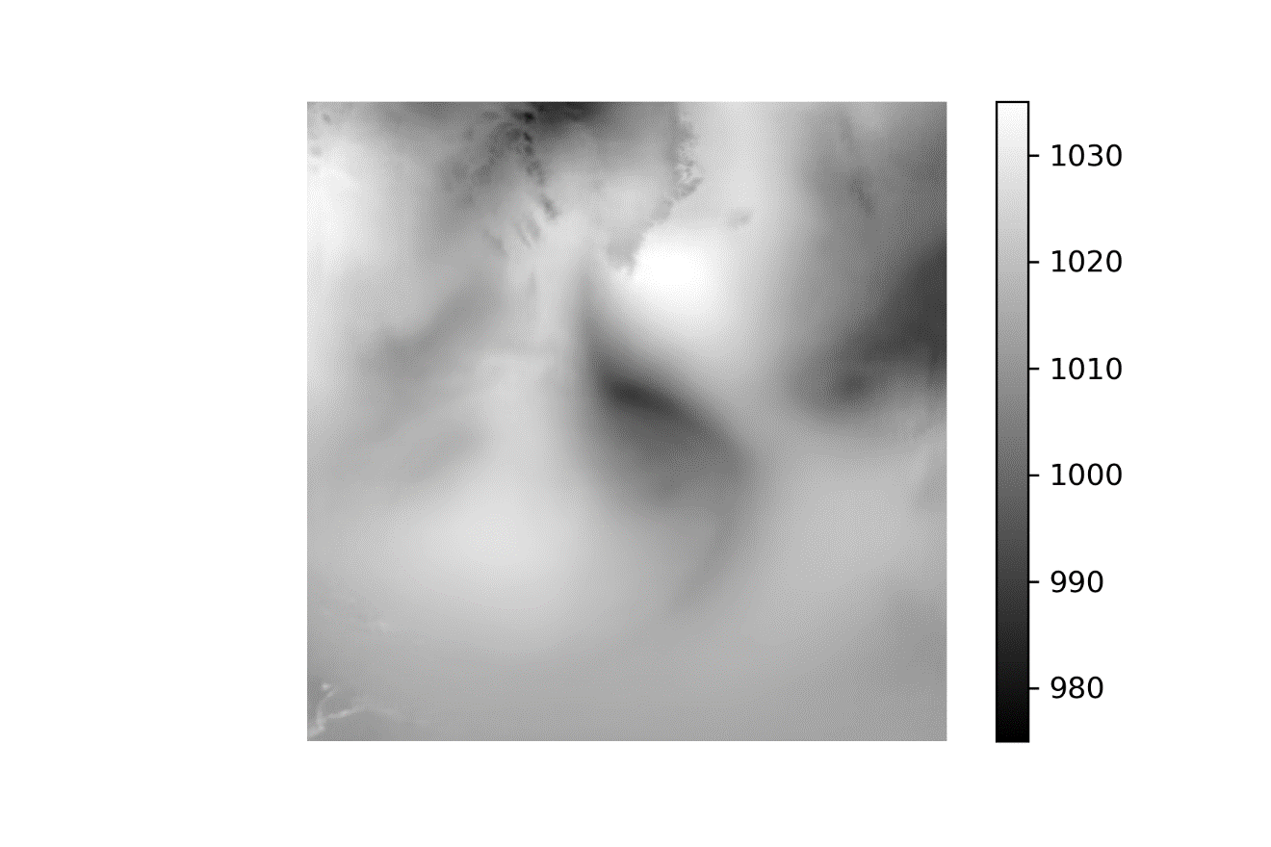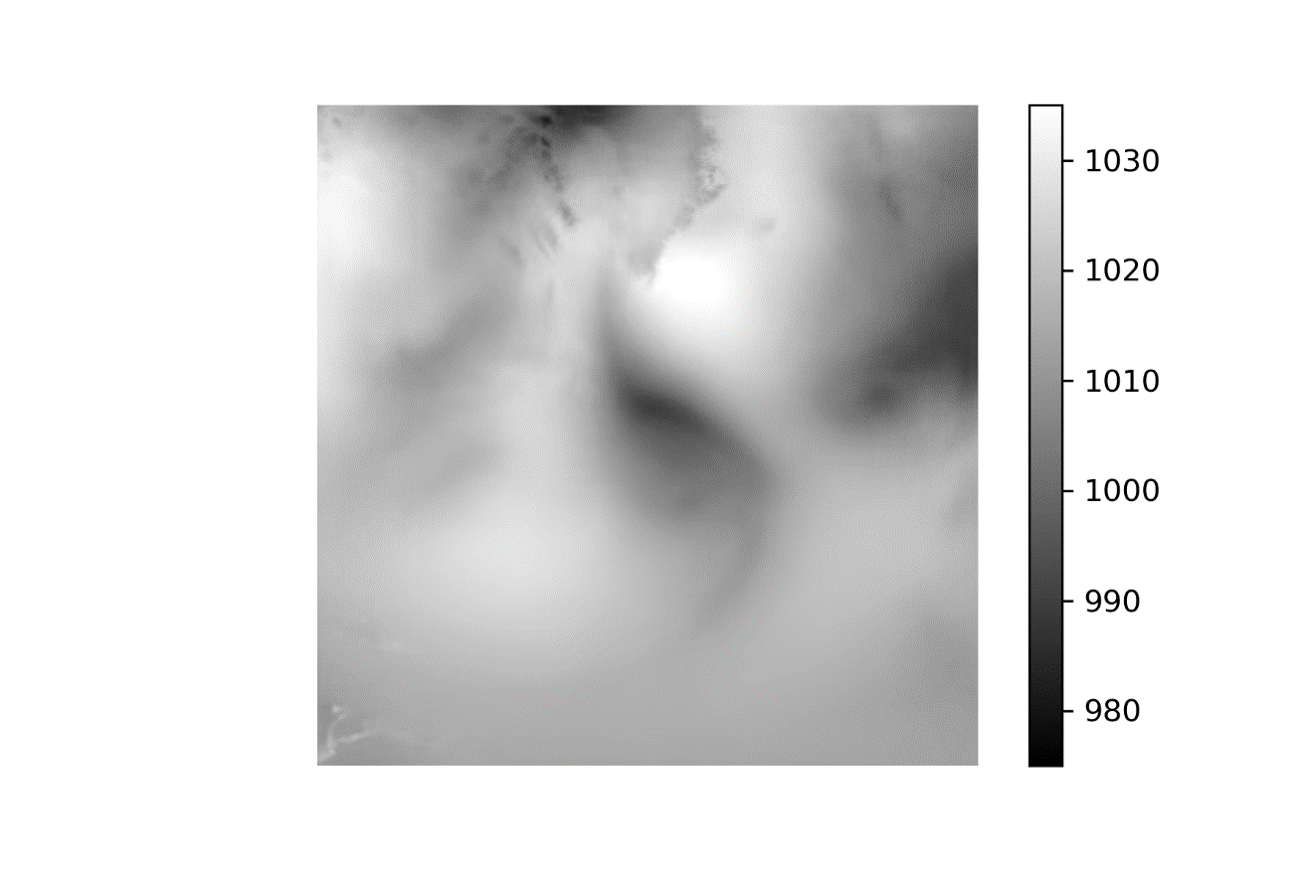 

1 Jul 2010 –-50-100-150-200-250-300-High

